SIMATS ENGINEERING (SAVEETHA SCHOOL OF ENGINEERING)
Department of Computer Science and Engineering
ASSESSMENT TOOL 1 – CONCEPT MAP

Course Code: | ITA03 | Course Title: | Mobile computing
CO Assessed: | CO1 | Assessment: | Assessment Tool 1 – Concept Map
Weightage: | 60 % of CIA | Total Marks: | 20 marks
CO1 Statement: | Analyse the mobile network components, mobile base station, mobile infrastructures and protocols in cellular systems.
Student Name: | Perugu Siva Kumar | Reg. No.: | 192311088
Section / Batch: | CSE | Date: | 30/10/2026

Code of Conduct

I ______Perugu Siva Kumar(192311088)_______ (Name / Reg. No) certify that this submission is my original work and that I have adhered to the guidelines specified for this assessment. I understand that any violation of academic integrity rules will result in disciplinary action.
Signature of the Student: ___P.SIVA KUMAR_____

Instructions
- This test contains ONE question.
- Duration: 30 minutes (At home)

Annexure A - QUESTIONS

- Construct a concept map that evaluates the effectiveness of roaming mechanisms in mobile communication.
Illustrate relationships among home network, visited network, authentication, registration, and billing.
Assess the importance of each process in successful roaming.
Support your conclusions through logical concept organization.

- Develop a concept map that evaluates the relationship between mobility, handoff, and roaming.
Illustrate their dependencies and interactions.
Determine which mechanism contributes most to uninterrupted communication.
Justify your evaluation using appropriate linking phrases.

- Design a concept map that evaluates the influence of cellular performance criteria.
Relate coverage, capacity, Quality of Service (QoS), reliability, throughput, and delay.
Assess which criteria most significantly affect user experience.
Justify the hierarchy established in the concept map.

- Construct a concept map that evaluates the effectiveness of various cellular system operations.
Include call setup, authentication, paging, resource allocation, handoff, and call termination.
Assess the contribution of each operation to overall network performance.
Support your evaluation through logical concept relationships.

- Develop a concept map that evaluates the complete mobile communication process.
Illustrate the interaction among user equipment, access network, core network, mobility management, and service delivery.
Determine the most critical stages in ensuring communication quality.
Justify your evaluation with meaningful linking phrases.

Rubrics for Calculation

Criteria | Weightage | Level 4 – Exemplary | Level 3 – Proficient | Level 2 – Developing | Level 1 – Beginning
Understanding of Problem Context | 20 | Clearly understands the problem and accurately identifies all requirements | Good understanding with minor gaps | Basic understanding; some requirements unclear | Poor understanding or misinterpretation of the problem
Application of Concepts | 30 | Accurately applies appropriate concepts to solve complex problems | Applies relevant concepts correctly with minor errors | Applies basic concepts with limited accuracy | Fails to apply appropriate concepts
Problem-Solving Approach | 20 | Logical, well-structured, and efficient approach | Mostly logical approach with minor gaps | Basic approach with some inconsistencies | Illogical or unclear approach
Accuracy of Solution | 20 | Completely correct solution with proper justification | Mostly correct with minor errors | Partially correct solution | Incorrect or incomplete solution
Clarity | 10 | Clear, well-organized, and properly explained solution | Understandable with minor clarity issues | Limited clarity and explanation | Poorly presented and difficult to understand

Faculty In-charge | Course Coordinator | Program Director
Signature: _______________ | Signature: _______________ | Signature: _______________
Date: ___________________ | Date: ___________________ | Date: ___________________

Question 11 – Effectiveness of Roaming Mechanisms
Question 11
Construct a concept map that evaluates the effectiveness of roaming mechanisms in mobile communication.
• Illustrate relationships among home network, visited network, authentication, registration, and billing.
• Assess the importance of each process in successful roaming.
• Support your conclusions through logical concept organization.

1. Introduction
Roaming is the capability that lets a subscriber keep using voice, SMS and data services when the subscriber is outside the coverage area of the operator with whom the subscription is held. The operator that owns the subscription is the Home Network (HPLMN – Home Public Land Mobile Network). The operator whose radio and switching infrastructure the subscriber uses while away is the Visited Network (VPLMN). Roaming is not a single function; it is a chain of cooperating processes – network selection, registration, authentication, subscriber-profile transfer, call/data routing, usage recording and inter-operator billing – that must all succeed for the user to experience 'my phone just works abroad'.
Roaming is evaluated as 'effective' when (a) the subscriber gets service quickly after entering a foreign network, (b) the subscriber's identity and the operators' revenue are protected, and (c) the home operator can correctly bill the subscriber and settle the money owed to the visited operator.

2. Key Concepts and Their Roles
Concept | Meaning | Role in roaming
Home Network (HPLMN) | Operator holding the subscription. Contains the HLR/HSS (master subscriber database) and AuC (Authentication Centre). | Stores the subscriber profile and secret key (Ki); decides whether the roamer is allowed; produces authentication vectors; bills the subscriber.
Visited Network (VPLMN) | Foreign operator providing radio access (BTS/BSC or eNodeB) and switching (MSC/VLR or MME/SGSN). | Provides the actual radio service; holds a temporary copy of the profile in the VLR; records usage for billing.
Roaming agreement | Commercial and technical contract between operators (technical data exchanged in IR.21 documents; tariffs in IR.31/IR.80-type documents). | Without an agreement, the VPLMN will not accept the visitor; it defines rates, services allowed and signalling links (SS7/Diameter; SEPP in 5G).
Registration (Location Update) | Procedure in which the MS reports its identity (IMSI/TMSI) and location area to the VLR, which informs the HLR. | Lets the network know where the roamer is so that incoming calls and SMS can be delivered.
Authentication | Challenge-response check: the network sends a random number RAND; the SIM answers with SRES computed using the secret key Ki. Ki never travels over the air. | Prevents SIM cloning and fraud; precondition for ciphering and for any service.
Billing | Visited network creates Call Detail Records (CDRs), converts them into TAP (Transferred Account Procedure) files, exchanged through a data clearing house; home operator then charges the subscriber. | Ensures the visited operator is paid and the subscriber is charged correctly (including inter-operator settlement and fraud control).

3. Concept Map
The concept map below places Roaming at the top (most general concept) and connects the supporting concepts with labelled links. Each arrow reads as a sentence: Concept → linking phrase → Concept. The links show the dependency flow from the subscriber to a successful, billed service.
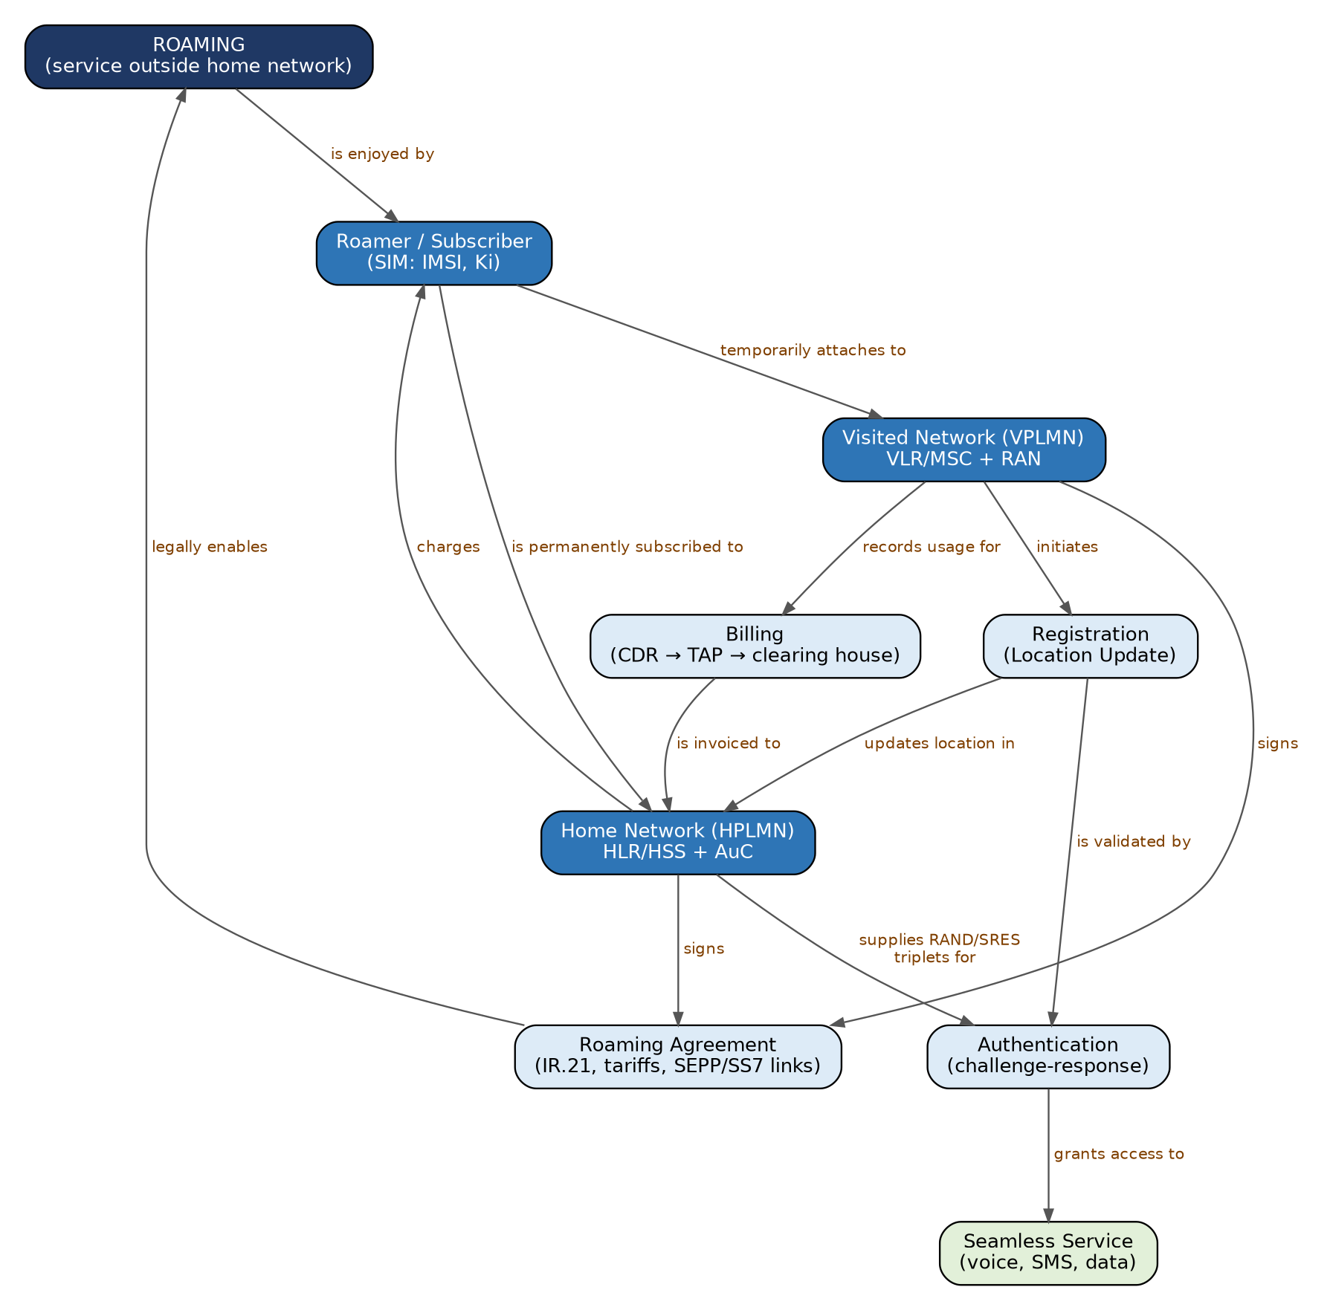
Figure 11.1 – Concept map of roaming mechanisms

4. Justification of Linking Phrases
Link | Why this phrase is justified
Roaming → 'is enjoyed by' → Roamer | Roaming exists only for the benefit of the subscriber; all other processes support this user-visible service.
Roamer → 'is permanently subscribed to' → Home Network | The SIM (IMSI, Ki) and the contract belong to one operator only – the HPLMN.
Roamer → 'temporarily attaches to' → Visited Network | Attachment lasts only while the user stays in the foreign coverage area; the VLR record is deleted when the user leaves.
Roaming Agreement → 'legally enables' → Roaming | Technical capability alone is not sufficient; operators must agree on tariffs, services and signalling connectivity.
Visited Network → 'initiates' → Registration | The VLR/MSC of the visited network receives the Location Update Request from the MS and starts the procedure.
Registration → 'updates location in' → Home Network | The HLR must always hold the address of the VLR/MSC currently serving the roamer, otherwise incoming calls cannot be routed.
Home Network → 'supplies RAND/SRES triplets for' → Authentication | Only the HPLMN's AuC knows Ki and can generate valid vectors; the visited network merely verifies the answer.
Authentication → 'grants access to' → Seamless Service | A successful challenge-response is the gate to ciphering, profile download and all services.
Visited Network → 'records usage for' → Billing | Only the VPLMN sees the actual calls, SMS and data volume, so it generates CDRs.
Billing → 'is invoiced to' → Home Network, Home Network → 'charges' → Roamer | The visited operator settles with the home operator (wholesale), and the home operator charges the subscriber (retail).

5. Flowchart – Roaming Procedure from Registration to Billing
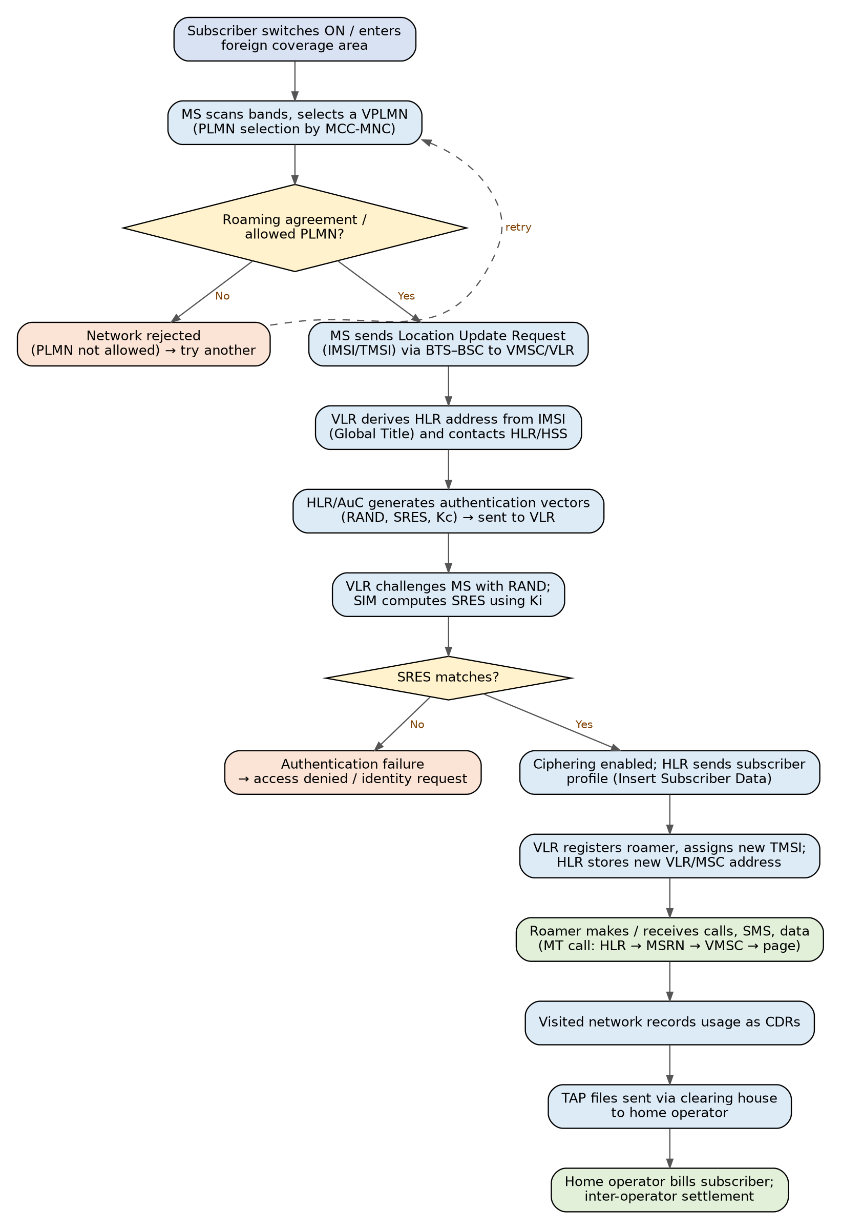
Figure 11.2 – Flowchart of the roaming process (registration, authentication, service and billing)

6. Step-by-Step Explanation of the Flowchart
- Network selection: When the phone enters a foreign country it scans for networks and chooses a VPLMN using the MCC-MNC code (country + network). It will only attempt networks listed as allowed on the SIM or the preferred-roaming list.
- Agreement check: If no roaming agreement exists, the network rejects the attempt (e.g., 'PLMN not allowed') and the phone tries another operator.
- Location Update Request: The MS sends its TMSI (or IMSI on first contact) to the visited MSC/VLR. The VLR reads the MCC-MNC-MSIN in the IMSI and works out the Global Title of the home HLR.
- Authentication vectors: The HLR/AuC computes RAND, SRES and the cipher key Kc using Ki and the A3/A8 algorithms (UMTS/LTE use AKA with RAND, XRES, CK, IK, AUTN) and sends them to the VLR.
- Challenge-response: The VLR sends RAND to the phone; the SIM calculates SRES and returns it. If SRES equals the stored value, the user is genuine; otherwise access is denied.
- Profile download and registration: The HLR sends the subscriber profile (supplementary services, barring, teleservices) to the VLR. The VLR allocates a new TMSI, and the HLR stores the new VLR/MSC address.
- Service usage: For outgoing calls the VMSC routes directly. For an incoming call the GMSC of the home network asks the HLR; the HLR asks the VLR for a Mobile Station Roaming Number (MSRN) and the call is routed to the visited MSC, which pages the phone.
- Billing: Visited network CDRs → TAP file → clearing house → home operator. The home operator applies retail tariffs and the subscriber receives one consolidated bill.

7. Assessment – Importance of Each Process
Rank | Process | Importance in successful roaming | Impact if it fails
1 | Authentication | Foundation of security and revenue protection; gates every other service. | Fraud, SIM cloning, or legitimate users locked out.
2 | Registration | Makes the roamer reachable and loads the profile into the VLR. | User can make no calls or cannot receive any (no MSRN).
3 | Roaming agreement / Home–Visited network cooperation | Legal and signalling basis; decides which networks and services are available. | Network not allowed; no signalling path to HLR.
4 | Billing | Commercial sustainability; does not affect the user at the moment of call but is critical for the operators. | Revenue leakage, bill shock, disputes, operators stop the agreement.
Conclusion of the assessment: Authentication and registration are the real-time 'gatekeeper' processes – if either fails the user receives no service at all. The roaming agreement is the prerequisite that makes them possible, and billing is the back-office process that keeps the whole ecosystem financially viable. Therefore the effectiveness of roaming depends first on security (authentication), then on location management (registration), and finally on commercial settlement (billing).

8. Additional Information
- Types of roaming: Intra-operator/national roaming (same country, other network), international roaming (other country), inter-technology roaming (e.g., 4G to 2G fall-back) and inter-circle roaming within India.
- Call routing models: In GSM, a call to a roamer is routed first to the home network (GMSC) and then forwarded to the visited network – this is why the caller may pay more or the roamer pays for the incoming leg. In 4G/5G data roaming, 'home-routed' traffic is tunnelled to the home network (good for control and lawful intercept) whereas 'local break-out' goes straight to the internet from the visited network (lower latency).
- Identity protection: The TMSI (temporary identity) is used over the air instead of the IMSI, so a listener cannot follow the subscriber.
- Steering of roaming: Home operators can steer subscribers to preferred partner networks to obtain lower wholesale rates.
- Regulation and 'bill shock': Many regions regulate roaming charges (e.g., EU 'Roam like at home'); operators send welcome SMS with tariffs and enforce data caps/alerts.
- Signalling protocols: SS7 MAP (2G/3G), Diameter (4G) and HTTP/2-based service-based interfaces with SEPP security gateways (5G).
- Common problems: Network not allowed, wrong APN, VoLTE/VoWiFi roaming not supported, SIM-lock, and signalling security attacks such as location tracking – addressed by SS7 firewalls and SEPP.

9. Conclusion
Roaming is effective only when home and visited networks cooperate across four chained processes: registration, authentication, service delivery and billing. The concept map shows that the Home Network is the 'trust anchor' (identity, keys, billing) while the Visited Network is the 'service provider' (radio, switching, usage recording). Authentication is the most critical process technically, whereas the roaming agreement and billing make it commercially possible.

Question 12 – Relationship between Mobility, Handoff and Roaming
Question 12
Develop a concept map that evaluates the relationship between mobility, handoff, and roaming.
• Illustrate their dependencies and interactions.
• Determine which mechanism contributes most to uninterrupted communication.
• Justify your evaluation using appropriate linking phrases.

1. Introduction
Mobility is the fundamental property of a mobile network: the user moves while the network must keep serving the user. Mobility itself creates three different problems, depending on where the user moves and what the phone is doing at that moment:
- Moving from one cell to another during a call or data session → handoff (handover) is needed.
- Moving from one location area to another while idle → location management (location/tracking-area update) is needed.
- Moving from one operator's network to another operator's network → roaming is needed.
Thus mobility is the cause (the 'why'), while handoff and roaming are two different mechanisms (the 'how') used to hide that movement from the user.

2. Comparison of Mobility, Handoff and Roaming
Aspect | Mobility | Handoff | Roaming
Nature | Overall property / umbrella concept | Mechanism for active sessions | Mechanism for service across operators
Trigger | User movement | Signal quality below threshold, cell edge, congestion | Entering a network not owned by the home operator
Phone state | Idle or active | Active (call/data in progress) | Idle registration and active use
Scope | Any movement | Between cells/channels/MSCs of (usually) one network | Between PLMNs (operators/countries)
Main entities | MS, network | MS, BTS/BSC/MSC (eNodeB/gNB, MME/AMF) | HLR/HSS, VLR/MSC, AuC, clearing house
Time scale | Continuous | Milliseconds to ~100 ms interruption | Seconds for registration; hours/days of stay
Failure result | — | Dropped call | No service / not allowed network
Key parameters | Speed, direction | RSS, BER/BLER, distance, timing advance, load, hysteresis | Roaming agreement, authentication, tariffs

3. Concept Map
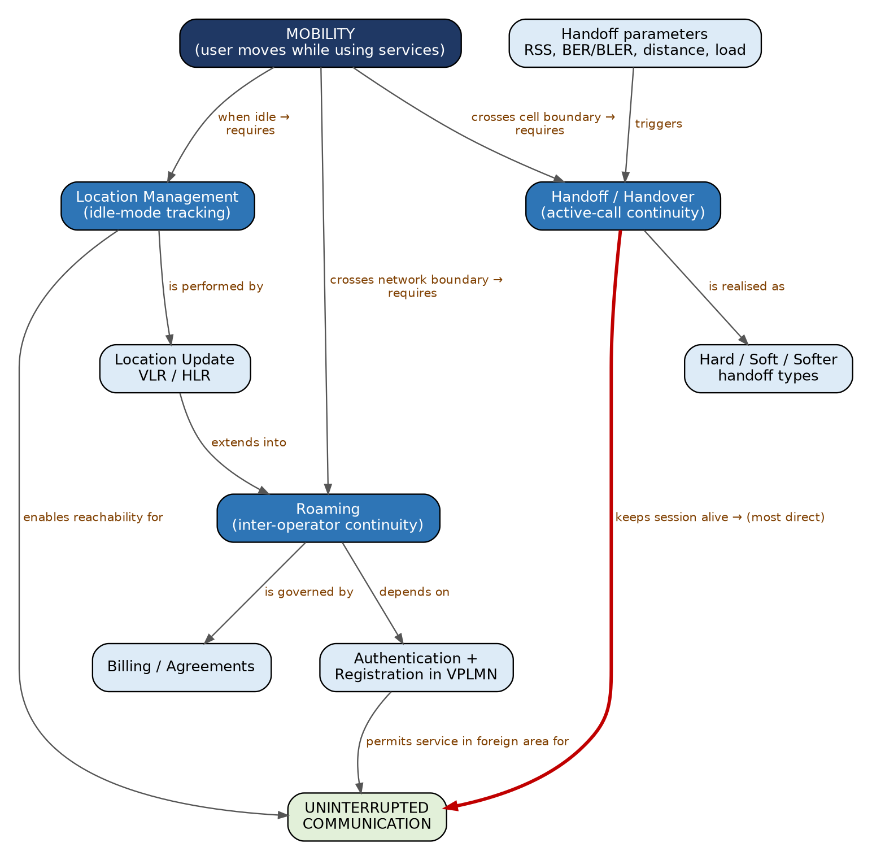
Figure 12.1 – Concept map relating mobility, handoff, location management and roaming

4. Justification of Linking Phrases
Link | Justification
Mobility → 'crosses cell boundary → requires' → Handoff | A moving user eventually leaves the serving cell's coverage; a call can survive only if the connection is passed to the next cell.
Mobility → 'when idle → requires' → Location Management | If no call is active the network does not follow the user continuously; the phone reports only when its location area changes so that paging stays accurate.
Mobility → 'crosses network boundary → requires' → Roaming | Leaving the home operator's footprint demands a different operator's resources, which is possible only by roaming.
Handoff parameters → 'trigger' → Handoff | Handoff decisions are driven by measurable quantities (RSS, BER, distance, traffic load, hysteresis margin).
Handoff → 'is realised as' → Hard/Soft/Softer | The technique depends on the access technology: hard (break-before-make, GSM/LTE), soft (make-before-break, CDMA/WCDMA).
Location Management → 'is performed by' → Location Update | Location updates are the signalling procedure that implements location management.
Location Update → 'extends into' → Roaming | When the new location area belongs to another PLMN, the same location update becomes a roaming registration.
Roaming → 'depends on' → Authentication + Registration | The visited network must verify the visitor and obtain the profile before offering service.
Handoff → 'keeps session alive' → Uninterrupted Communication (bold arrow) | Handoff is the only mechanism that acts while a call is in progress; it directly prevents call drops.
Location Management / Roaming → 'enables reachability' / 'permits service' → Uninterrupted Communication | They secure continuity in the idle state and across operators, but they do not rescue a call that is already on the air.

5. Flowchart – Decision Flow for a Moving User
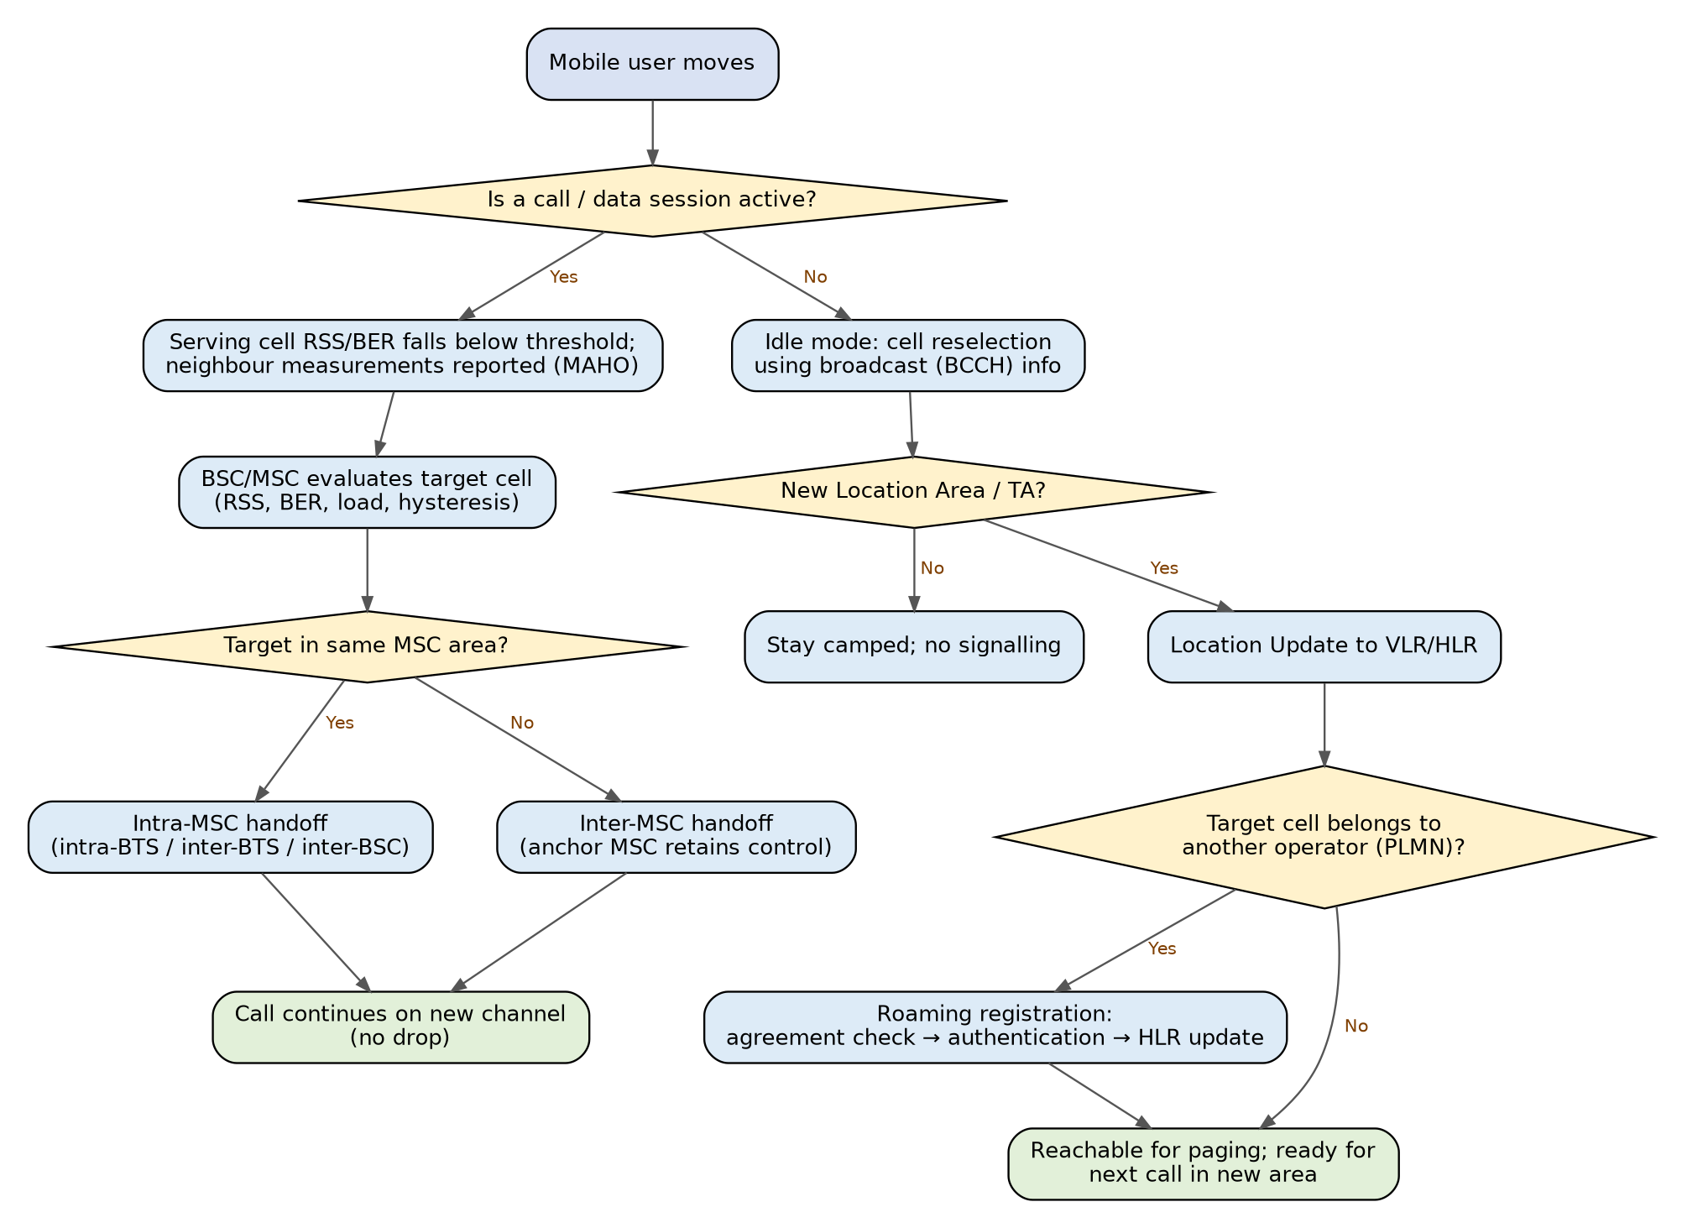
Figure 12.2 – Flowchart showing when handoff, location update or roaming is triggered

6. Explanation of the Flowchart
- Active session path: The MS continuously measures serving and neighbouring cells (MAHO – Mobile Assisted Handoff) and reports to the BSC. When RSS or quality falls below the threshold and a neighbour is better by a hysteresis margin (to avoid ping-pong), the network prepares the target cell, orders the MS to the new channel and releases the old one. If the target is in another MSC area, the anchor MSC keeps control and a relay (E-interface) is set up (inter-MSC handoff).
- Idle path: The phone performs cell reselection using BCCH/SIB information. If the new cell is in a different location area (tracking area in LTE/5G), it sends a location update so that paging goes to the right area.
- Network boundary: If the new cell belongs to a different operator, the update becomes a roaming registration – agreement check, authentication, HLR update – exactly as in Question 11.

7. Assessment – Which Mechanism Contributes Most to Uninterrupted Communication?
Mechanism | Contribution | Limitation | Score (out of 10)*
Handoff | Directly maintains an ongoing call/data session while the user moves; interruption is only a few tens of milliseconds. | Works mostly within one network; inter-operator handover depends on agreements and is often replaced by re-registration. | 9
Location management | Keeps idle users reachable; reduces paging load. | Does nothing for a call already in progress. | 7
Roaming | Extends service area beyond the home operator. | Needs agreements; mostly seen at session start rather than during a call. | 7
Mobility (concept) | Cause rather than solution. | Not a mechanism by itself. | —
*The scores are an evaluation judgement for this concept map, not standardised measurements.
Conclusion: Handoff contributes most to uninterrupted communication, because it is the only mechanism that repairs the radio connection while the conversation is taking place. Roaming provides the 'wide-area' continuity (service in any country), and location management provides 'reachability' in the idle state. All three are triggered by mobility and all three rely on the same registration and authentication infrastructure.

8. Additional Information
- Handoff classes in GSM: Intra-BTS (channel change in same cell), inter-BTS intra-BSC, inter-BSC intra-MSC (MSC involved) and inter-MSC (anchor MSC + target MSC).
- Hard vs soft handoff: Hard = break-before-make, one radio link at a time (GSM, LTE). Soft = make-before-break, several links simultaneously (CDMA/WCDMA). Softer = soft handoff between sectors of the same base station.
- Handoff failure causes: Late decision, no free channel in target cell (blocking), signalling delay at high speed, coverage holes. Remedies: guard channels, hysteresis and time-to-trigger tuning, handoff priority over new calls.
- Ping-pong effect: Repeated back-and-forth handoffs near a cell boundary; reduced using a hysteresis margin and time-to-trigger.
- Mobility models and prediction: Random-walk, fluid-flow and Markov models estimate boundary-crossing rates, used to dimension location areas and handoff signalling.
- Evolution: In 4G the X2/S1 handovers and in 5G Xn/NG handovers have improved speed; 5G supports conditional handover and dual connectivity for near-zero interruption.

9. Conclusion
Mobility is the driving force; handoff, location management and roaming are the three answers the network gives at three different levels – cell, location area and operator. The concept map shows that although all are dependent on each other, handoff has the strongest contribution to uninterrupted communication, since it protects live sessions.

Question 13 – Influence of Cellular Performance Criteria
Question 13
Design a concept map that evaluates the influence of cellular performance criteria.
• Relate coverage, capacity, Quality of Service (QoS), reliability, throughput, and delay.
• Assess which criteria most significantly affect user experience.
• Justify the hierarchy established in the concept map.

1. Introduction
Performance criteria are the measurable yardsticks used to decide whether a cellular network is 'good'. Operators plan, optimise and sell their networks by these criteria, and users judge their operator by them (even though users only say 'there is no signal' or 'video keeps buffering'). The six criteria are interrelated: improving one often sacrifices another, so evaluation requires understanding both the individual meaning and the trade-offs.

2. Definitions, Metrics and Typical Targets
Criterion | Definition | Typical metrics | Typical target / note
Coverage | Geographic area where signal is strong enough to start and hold a call/data session. | RSSI, RSRP/RSRQ, SINR, link budget, cell radius, coverage probability (area/edge) | e.g., RSRP better than about −100 dBm for usable LTE service; 90–98% area coverage targets.
Capacity | Maximum traffic or number of users the system can serve at required quality. | Erlangs, simultaneous users per cell, bits/s/Hz/cell, channels per cell | Raised by frequency reuse, sectoring, cell splitting, more spectrum, higher spectral efficiency.
Throughput | Rate of successful data delivery. | Mbps (peak, average, cell-edge), goodput | Cell-edge rate matters more than peak rate for user satisfaction.
Delay (latency) | Time to deliver information or set up a service. | Call setup time, one-way/round-trip latency, jitter, handoff interruption | Voice < about 150 ms one-way; 4G ~10–50 ms; 5G URLLC target ~1 ms.
Reliability | Probability that the network works correctly as expected. | Availability (e.g., 99.99%), call setup success rate, call drop rate, BLER/BER, handoff success rate | Carrier-grade 'five nines' (99.999%) for core elements.
QoS | Overall treatment a service receives; combination of the above for each service type. | Blocking probability (GoS), MOS (voice quality), packet loss, 5QI/QCI classes | Different for voice, video, gaming, IoT, mission-critical.

Capacity can be linked to physical limits through Shannon's formula C = B·log₂(1 + SNR), where B is bandwidth in Hz and SNR is signal-to-noise ratio, and to traffic engineering through the Erlang B formula, which gives the blocking probability for a given traffic load and number of channels. In a reuse-based system, capacity increases when the cluster size N falls (more reuse), but co-channel interference rises – a typical trade-off.

3. Concept Map
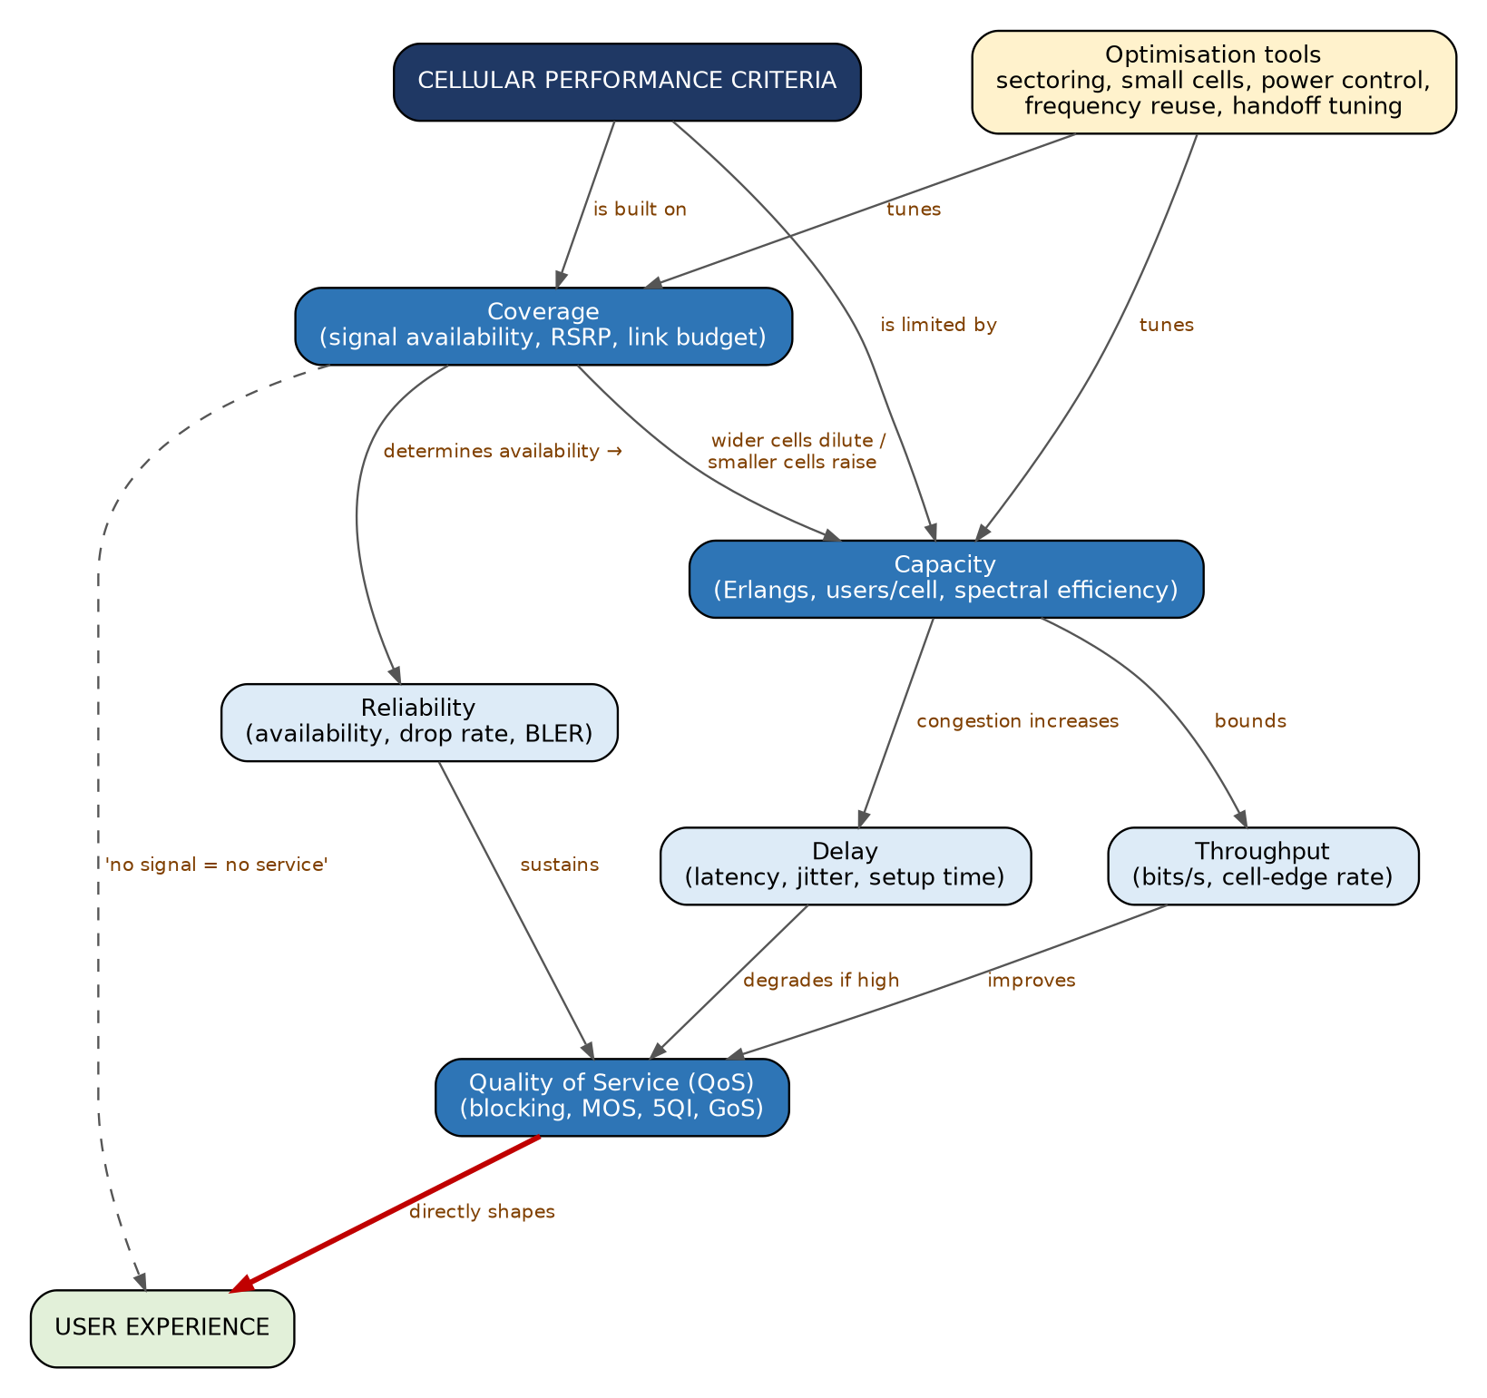
Figure 13.1 – Concept map of cellular performance criteria and their hierarchy

4. Justification of the Hierarchy and Linking Phrases
The hierarchy has three levels. Level 1 (foundation) contains coverage and capacity because they decide whether service can exist and how many users it can serve. Level 2 (service characteristics) contains throughput, delay and reliability, which describe how the service behaves. Level 3 (integrating level) is QoS, which combines level 2 for each service and leads directly to user experience.
Link | Justification
Performance → 'is built on' → Coverage | If there is no radio signal at the location, no other criterion can be achieved.
Performance → 'is limited by' → Capacity | Even with good signal, a finite spectrum limits the number of simultaneous users.
Coverage → 'determines availability' → Reliability | Coverage holes and weak signal cause call drops and failed setups.
Coverage → 'wider cells dilute / smaller cells raise' → Capacity | Large cells give broad coverage but spread few channels over a large area; small cells reuse frequency more and add capacity.
Capacity → 'bounds' → Throughput | The aggregate data rate is shared among users in a cell; more users means less rate for each.
Capacity → 'congestion increases' → Delay | As load approaches capacity, queues grow, scheduling waits lengthen and setup takes longer.
Throughput → 'improves' → QoS | Adequate data rate is needed for video, downloads and streaming.
Delay → 'degrades if high' → QoS | Real-time applications (voice, gaming) are very sensitive to latency and jitter.
Reliability → 'sustains' → QoS | Dropped calls and outages ruin even high-rate services.
QoS → 'directly shapes' → User Experience (bold arrow) | QoS is what the user actually perceives – clarity of voice, smoothness of video, speed of page load.
Coverage → 'no signal = no service' → User Experience (dashed) | Shows that coverage is also a direct, 'binary' influence on satisfaction.
Optimisation tools → 'tune' → Coverage / Capacity | Sectoring, small cells, power control, frequency reuse and handoff tuning are used to balance these two basic criteria.

5. Flowchart – Performance Evaluation and Optimisation Cycle
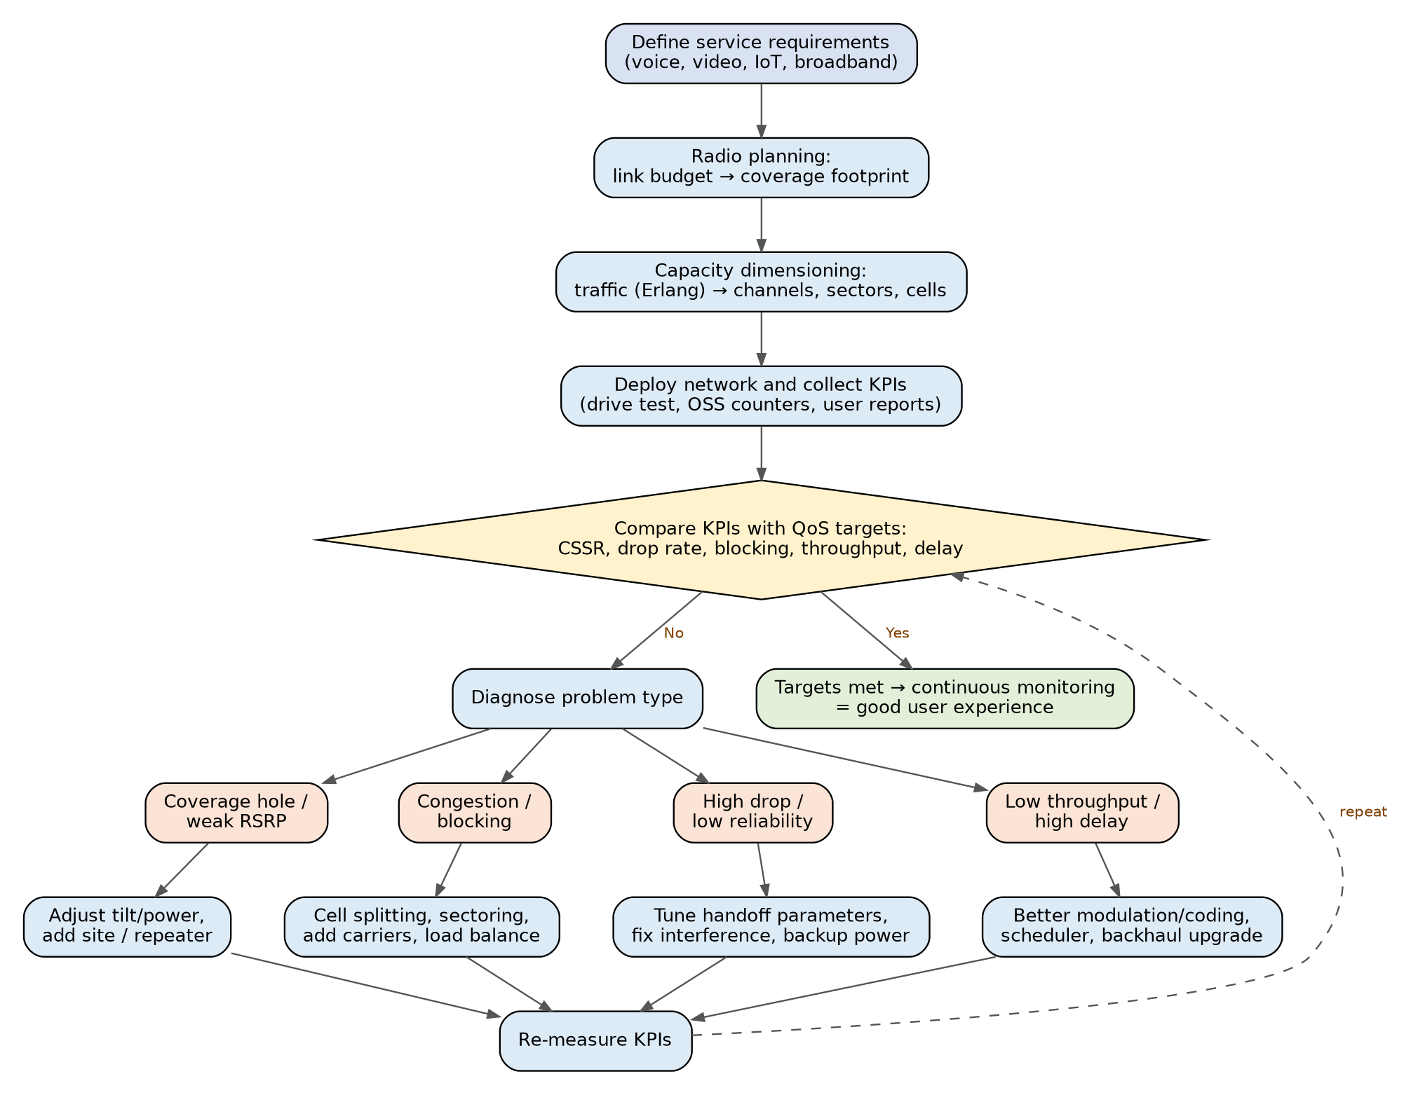
Figure 13.2 – Flowchart of performance planning, measurement, diagnosis and optimisation

6. Explanation of the Flowchart
- Define requirements: Decide what services (voice, video, IoT) and what quality levels are required.
- Radio planning: Use link budget (transmit power, antenna gains, path loss, fade margin, receiver sensitivity) to decide cell radius and site locations → coverage.
- Capacity dimensioning: Estimate busy-hour traffic in Erlangs and use Erlang B to determine channels, sectors, carriers and cell splits.
- Measure KPIs: Drive tests, OSS counters and crowd-sourced data provide values for call setup success rate (CSSR), drop rate, blocking, handoff success, throughput and latency.
- Compare and diagnose: If targets are not met, classify the problem – coverage hole, congestion, poor reliability, or low throughput/high delay.
- Optimise and repeat: Apply the appropriate fix and re-measure. The cycle is continuous because traffic, buildings and user behaviour keep changing.

7. Assessment – Which Criteria Influence User Experience the Most?
Rank | Criterion | Influence on user experience | Reason
1 | QoS (integrating criterion) | Very high | It is the combined, service-specific result that the user feels.
2 | Coverage | Very high | Absence of signal makes all other criteria meaningless; most common user complaint.
3 | Reliability | High | Dropped calls and failed sessions are remembered strongly by users.
4 | Delay | High for real-time services | Voice, video calling and gaming degrade quickly with latency/jitter.
5 | Throughput | High for data services | Determines download/streaming speed, especially at the cell edge.
6 | Capacity | Indirect | Noticed only when overloaded (blocking, slow speeds in crowds); mainly an operator planning criterion.
Note: The ranking is a reasoned evaluation for a typical mixed voice/data user. For a gamer, delay may rank above reliability; for an IoT meter, coverage and reliability dominate while throughput is almost irrelevant.

8. Trade-offs Between Criteria
- Coverage vs capacity: Large macro-cells maximise coverage; small cells maximise capacity. Heterogeneous networks use both.
- Throughput vs reliability: High-order modulation (64/256-QAM) gives high throughput but needs strong signal; robust coding (QPSK) is more reliable at the cell edge but slower.
- Capacity vs QoS: Accepting more users than the design capacity increases blocking, delay and dropped calls.
- Delay vs throughput: Large buffers and retransmissions raise reliable throughput but add delay.

9. Additional Information
- Grade of Service (GoS): Probability that a new call is blocked (typically 1–2% in the busy hour).
- MOS (Mean Opinion Score): 1–5 scale for voice quality; above about 4.0 is regarded as good.
- Techniques that improve performance: Sectoring (3 or 6 sectors), cell splitting, microcells/picocells/femtocells, MIMO and beamforming, power control, dynamic channel allocation, carrier aggregation and network densification.
- 5G service classes: eMBB (high throughput), URLLC (low delay, high reliability) and mMTC (massive device capacity) show how different criteria are prioritised by service type.

10. Conclusion
Coverage and capacity form the base on which throughput, delay and reliability are built, and these three together decide QoS, the criterion that translates network engineering into user experience. A hierarchical concept map therefore shows QoS at the top (what the user feels) and coverage/capacity at the bottom (what the engineer plans).

Question 14 – Effectiveness of Cellular System Operations
Question 14
Construct a concept map that evaluates the effectiveness of various cellular system operations.
• Include call setup, authentication, paging, resource allocation, handoff, and call termination.
• Assess the contribution of each operation to overall network performance.
• Support your evaluation through logical concept relationships.

1. Introduction
A cellular network performs a sequence of operations every time a user makes or receives a call: the network must find the user (paging), set up signalling, verify the user's identity (authentication), give radio and switching resources (resource allocation), keep the call connected as the user moves (handoff) and finally release everything (call termination). Each operation has its own success measure, and together they determine the overall network performance – call setup success rate, blocking, drop rate, security and capacity.

2. The Operations Explained
Operation | What happens | Channels / elements involved | Performance indicator
Paging | Network locates the called MS within its location area by broadcasting its TMSI/IMSI. Used for mobile-terminated (incoming) calls and SMS. The MS answers on RACH. | PCH (Paging Channel), AGCH, MSC/VLR, BSC, BTS | Paging success rate; paging load
Call setup | Signalling needed to create the connection: channel request, immediate assignment, service request, SETUP, CALL PROCEEDING, ALERTING, CONNECT. | RACH, AGCH, SDCCH, DTAP messages, MSC | Call setup success rate (CSSR); setup time
Authentication | Challenge-response with RAND/SRES, followed by start of ciphering (Kc) and TMSI reallocation. | VLR, HLR/AuC, SIM | Authentication success rate; fraud level
Resource allocation | Assignment of SDCCH for signalling and a TCH (time slot/frequency) for the conversation; power level and timing advance set; trunk circuits reserved in the core. | BSC, BTS, MSC, TCH/SACCH | Blocking probability, channel utilisation, capacity
Handoff | Transfer of the call to another channel/cell when quality is low or the user moves. | BSC/MSC, SACCH measurement reports, neighbour list | Handoff success rate; call drop rate
Call termination | Either party hangs up: DISCONNECT, RELEASE, RELEASE COMPLETE; the TCH and circuits are freed; CDR generated. | MS, BSC, MSC, billing system | Normal release rate; accurate CDRs; resources recycled

3. Concept Map
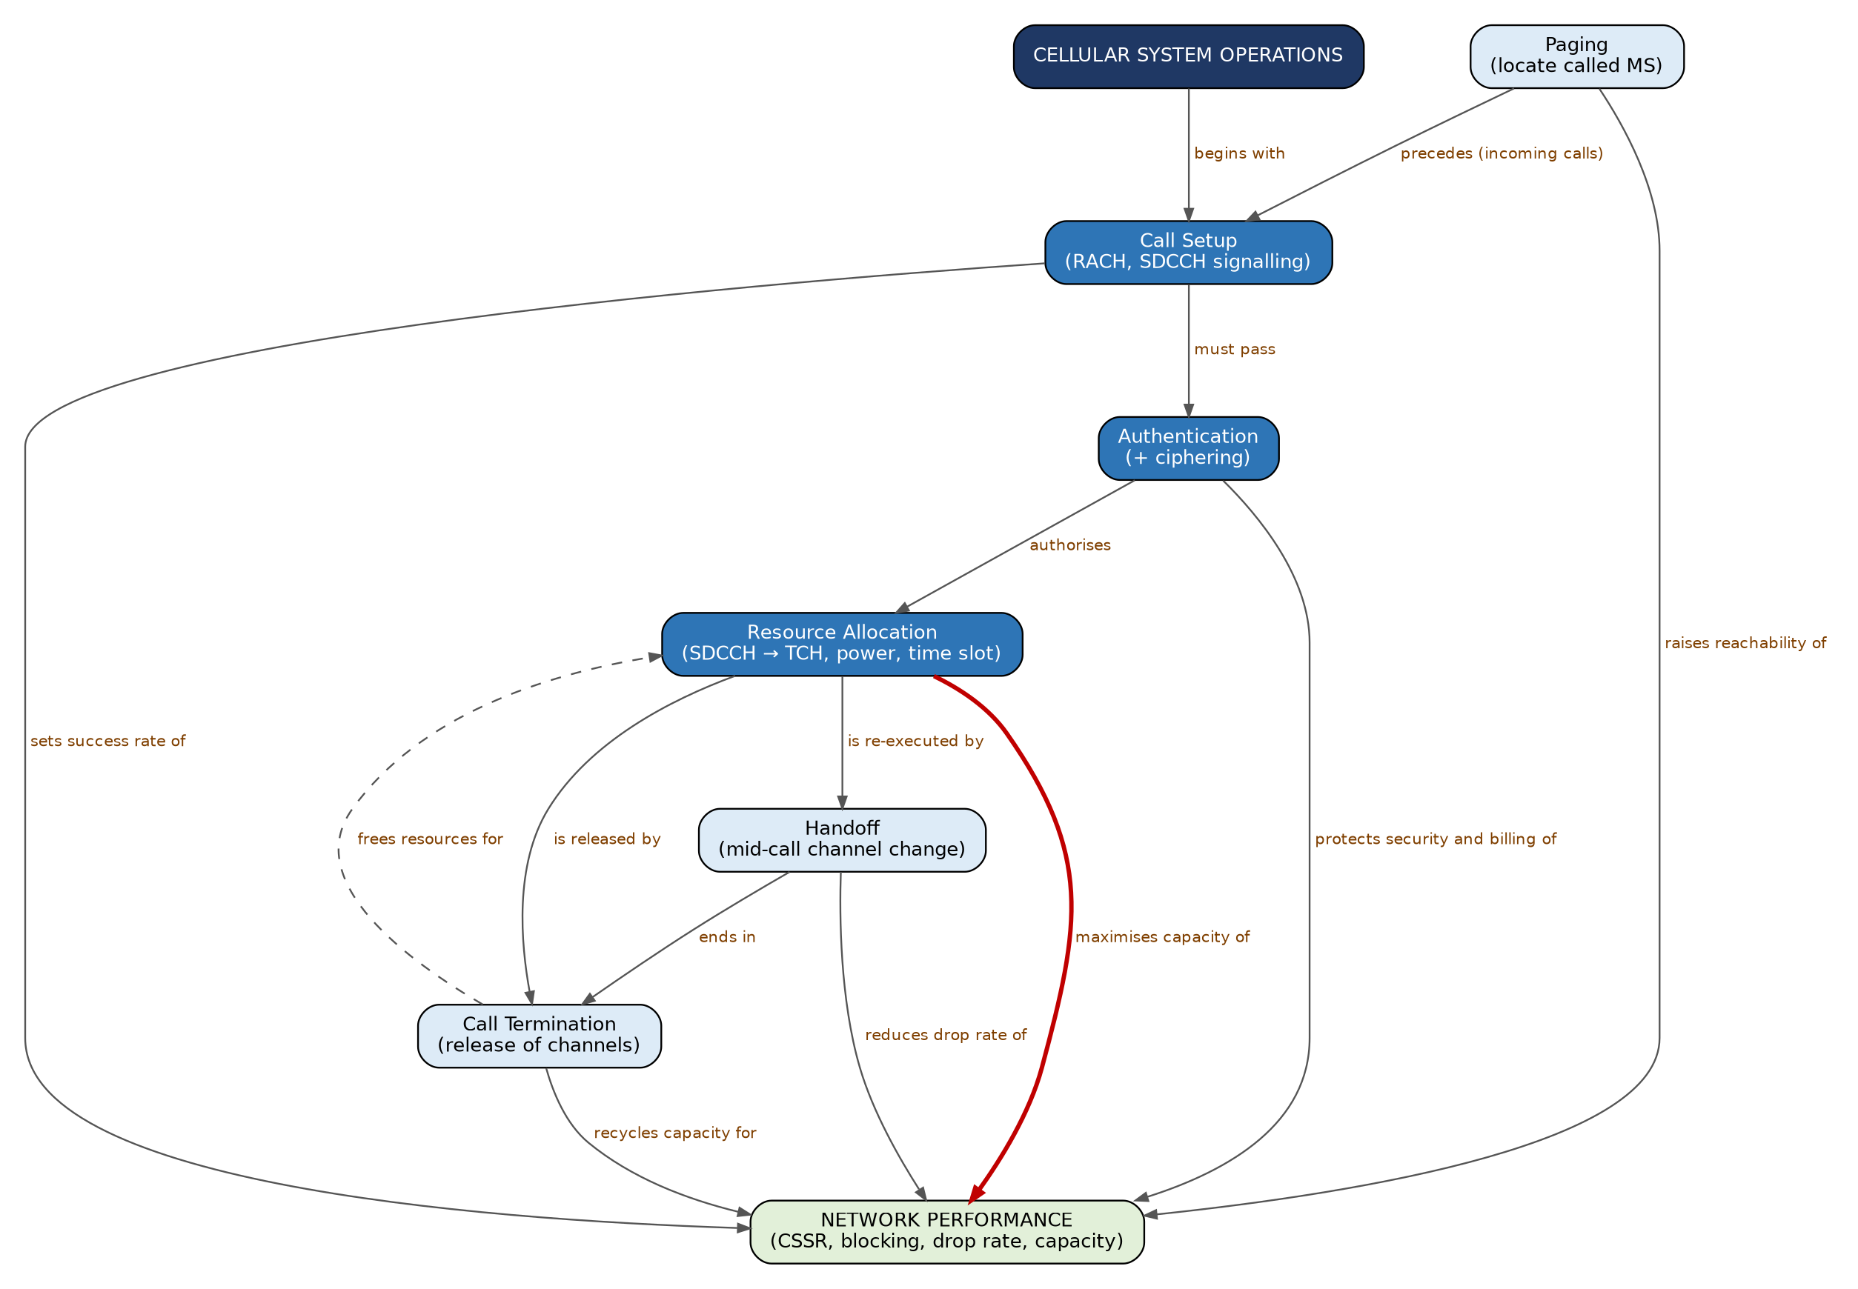
Figure 14.1 – Concept map of cellular system operations and their effect on network performance

4. Justification of Linking Phrases
Link | Justification
Cellular System Operations → 'begins with' → Call Setup | Every service starts with a setup attempt (MO or MT).
Paging → 'precedes (incoming calls)' → Call Setup | For a mobile-terminated call the network must first locate the MS before signalling can be established; for outgoing calls paging is skipped.
Call Setup → 'must pass' → Authentication | No resources are given before identity is proven; authentication occurs within the setup signalling on the SDCCH.
Authentication → 'authorises' → Resource Allocation | Only a validated user is given a traffic channel – protecting capacity and revenue.
Resource Allocation → 'is re-executed by' → Handoff | A handoff is essentially a fresh allocation of resources in the target cell.
Resource Allocation → 'is released by' → Call Termination | Termination returns channels to the pool.
Handoff → 'ends in' → Call Termination | A call that has been handed off still finishes with normal release.
Call Termination → 'frees resources for' → Resource Allocation (dashed) | Cyclic behaviour: released channels are available for the next caller.
Authentication → 'protects security and billing of' → Network Performance | Prevents fraud/cloning and ensures correct billing.
Resource Allocation → 'maximises capacity of' → Network Performance (bold) | Efficient allocation (power control, dynamic allocation, guard channels) determines how many calls can be carried at a given quality.
Handoff → 'reduces drop rate of' → Network Performance | Successful handoff is the main protection against call drops.
Paging → 'raises reachability of' / Call Setup → 'sets success rate of' / Call Termination → 'recycles capacity for' → Network Performance | Each operation affects one KPI directly: paging success, CSSR, blocking.

5. Flowchart – Call Lifecycle (Incoming and Outgoing)
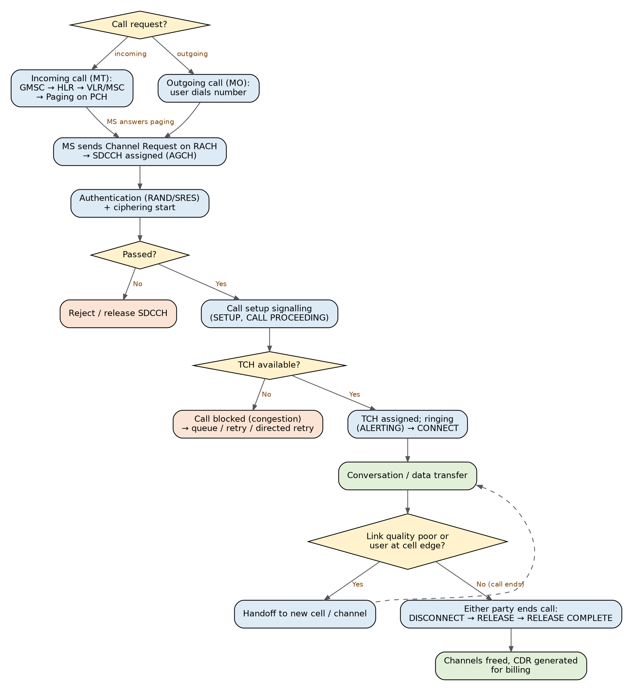
Figure 14.2 – Flowchart of call setup, authentication, resource allocation, handoff and termination

6. Explanation of the Flowchart
- Request: An outgoing call (MO) starts when the user dials; an incoming call (MT) starts when the calling party's request reaches the GMSC, which queries the HLR and the VLR and pages the MS in its location area.
- Signalling channel: The MS sends a Channel Request on the RACH (random access, may collide and be retried) and receives an Immediate Assignment of an SDCCH on the AGCH.
- Authentication and ciphering: On the SDCCH the network authenticates the MS and starts encryption. Failure results in release of the SDCCH.
- Call setup: SETUP and CALL PROCEEDING messages are exchanged; the MSC routes towards the called party.
- Traffic channel assignment: If a TCH is free, the BSC sends an Assignment Command; if none is free the call is blocked (or directed retry to another cell is attempted).
- Conversation: The call is carried on the TCH; the SACCH carries measurement reports and power/timing control.
- Handoff: If quality is poor or the user is at the cell edge, a handoff moves the call to a new cell/channel without interruption; the loop returns to conversation.
- Termination: DISCONNECT → RELEASE → RELEASE COMPLETE; resources are freed and a CDR is created.

7. Assessment – Contribution of Each Operation to Network Performance
Rank | Operation | Main contribution | KPI affected | Risk if ineffective
1 | Resource allocation | Controls how many users are served and how well; heart of capacity and QoS. | Blocking, capacity, interference | Congestion, wasted spectrum
2 | Handoff | Provides continuity during mobility. | Drop rate, HO success rate | Dropped calls, poor user perception
3 | Authentication | Security, billing integrity, resource protection. | Fraud level, authentication success | Cloning, revenue loss
4 | Call setup | Gateway to service; sets user's first impression. | CSSR, setup time | Failed or slow connections
5 | Paging | Reachability for incoming calls. | Paging success, signalling load | Missed calls; over-paging congests PCH
6 | Call termination | Releases resources and produces billing data. | Normal release rate, CDR accuracy | Hanging resources, billing errors
Evaluation: All six operations form a chain – a weak link anywhere damages the overall result. However, resource allocation has the largest influence on efficiency/capacity, handoff on continuity, and authentication on trust. Paging and termination are 'supporting' operations; they have less visible impact but, when mismanaged (for example, oversized location areas that flood paging, or calls that do not release), they cause hidden congestion.

8. Additional Information
- Logical channels: BCCH (broadcast system information), FCCH/SCH (frequency and timing synchronisation), CCCH = PCH + RACH + AGCH, SDCCH (stand-alone dedicated signalling), SACCH/FACCH (associated control), TCH (voice/data).
- Mobile-originated vs mobile-terminated: MO has no paging; MT begins with HLR interrogation → MSRN → paging response.
- Call-blocking handling: Directed retry, queuing, guard channels for handoff, half-rate channels and dynamic channel allocation.
- Authentication in later generations: UMTS/LTE use mutual authentication (AKA with AUTN), so the network is also verified by the phone, defeating fake base stations; 5G adds SUCI to hide the permanent identity.
- Evolution of operations: In LTE/5G, the same steps appear as RRC connection setup, NAS authentication/security mode command, bearer (PDU session) establishment, X2/Xn handover and RRC release.
- Important KPIs: CSSR, call drop rate (CDR), handoff success rate (HOSR), blocking, paging success rate, SDCCH congestion, TCH congestion.

9. Conclusion
The operations of a cellular system form a life-cycle – find, set up, verify, allocate, maintain, release – and the concept map shows that each stage feeds the next and finally the network performance. Resource allocation, supported by authentication and handoff, has the greatest effect on efficient and reliable service.

Question 15 – The Complete Mobile Communication Process
Question 15
Develop a concept map that evaluates the complete mobile communication process.
• Illustrate the interaction among user equipment, access network, core network, mobility management, and service delivery.
• Determine the most critical stages in ensuring communication quality.
• Justify your evaluation with meaningful linking phrases.

1. Introduction
A mobile phone call or data session seems simple to the user but involves a cooperating chain of subsystems: the User Equipment (UE) that generates and receives radio signals, the Access Network that provides the radio link, the Core Network that authenticates, routes, charges and connects to external networks, Mobility Management that keeps track of the user, and Service Delivery that provides the final voice, SMS or internet service. 'Quality' of communication is the outcome of every one of these stages; a weakness in one stage limits the whole chain (the 'weakest-link' principle).

2. Components and Their Roles
Component | Description | Role | Generation examples
User Equipment (UE) | Handset/modem + SIM/USIM with IMSI and secret key; antenna, baseband, codecs. | Originates/terminates traffic; measures cells; performs authentication; encodes speech and data. | 2G: MS; 3G: UE; 4G: UE; 5G: UE
Access Network | Radio base stations and controllers that provide the air interface and manage radio resources. | Radio access, channel assignment, power control, handoff execution, forwarding data to the core. | 2G: BTS + BSC; 3G: NodeB + RNC; 4G: eNodeB; 5G: gNB
Core Network | Switching, routing and database nodes. | Authentication, location registration, call/session control, IP routing, QoS policy, charging, gateways to PSTN/Internet. | 2G: MSC, VLR, HLR, AuC, GMSC; 4G: MME, S-GW, P-GW, HSS, PCRF; 5G: AMF, SMF, UPF, UDM, AUSF, PCF
Mobility Management | Procedures that track and maintain the connection of a moving user. | Attach/registration, location/tracking-area update, paging, handoff, roaming. | MM in GSM; EMM/ECM in LTE; 5GMM/5GSM in 5G
Service Delivery | The user-visible services and the transport that carries them. | Voice (circuit/VoLTE), SMS, internet, video, IoT, emergency calls. | Teleservices, bearer services, supplementary services; IMS in 4G/5G

3. Concept Map
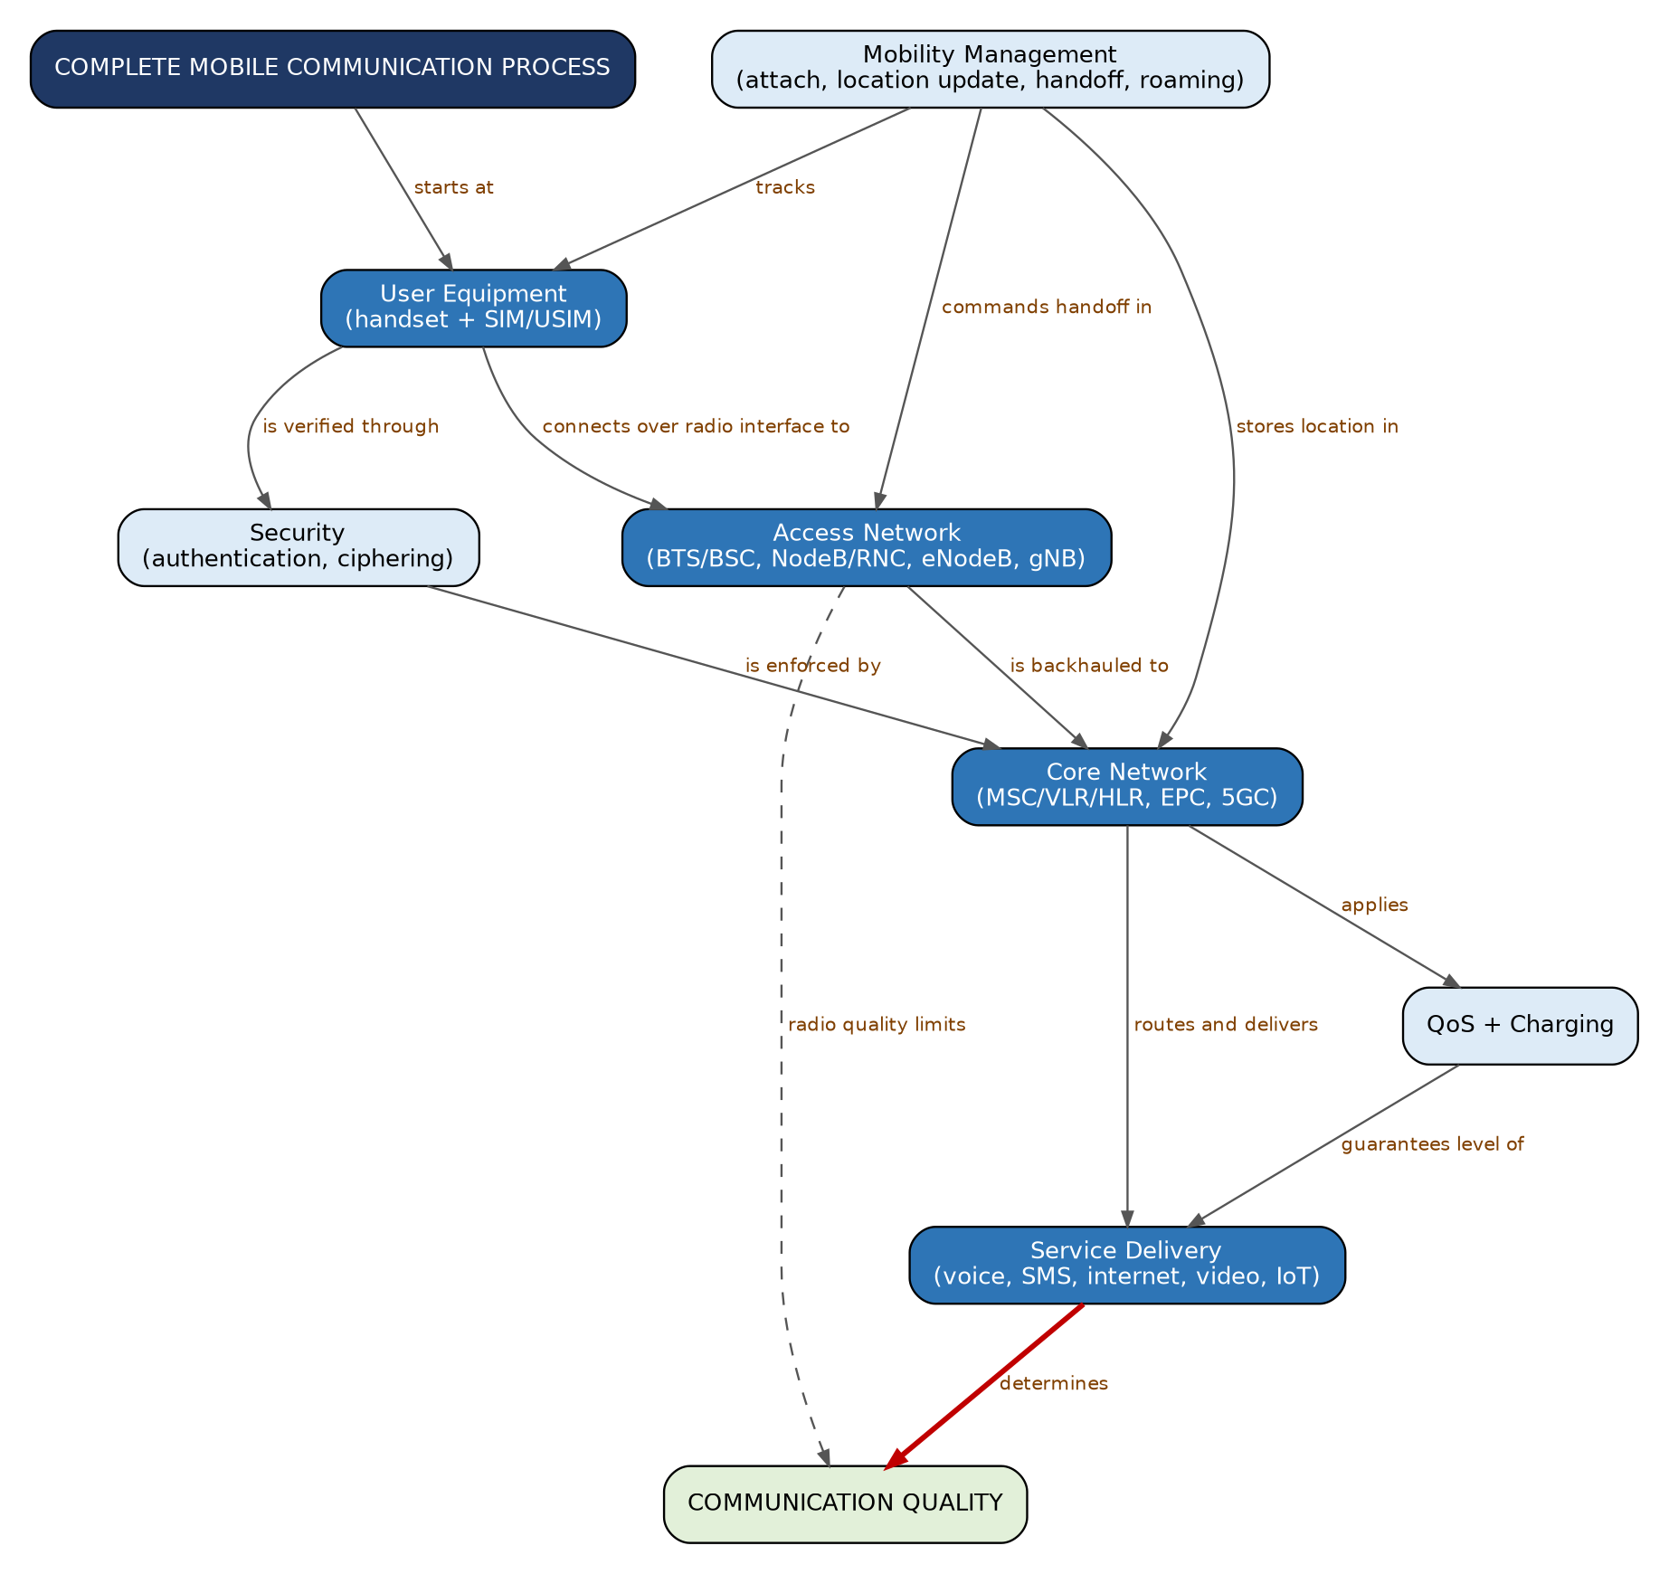
Figure 15.1 – Concept map of the complete mobile communication process

4. Justification of Linking Phrases
Link | Justification
Process → 'starts at' → User Equipment | Every communication starts when the device is switched on or a user acts.
UE → 'connects over radio interface to' → Access Network | The only wireless part; the radio interface (Um/Uu/LTE-Uu/NR-Uu) joins device and network.
Access Network → 'is backhauled to' → Core Network | Base stations pass signalling and user traffic to the core through fibre/microwave links (A-bis/A, Iub/Iu, S1/NG).
Core Network → 'routes and delivers' → Service Delivery | Switching and routing in the core connect the user to the called party, the internet or other services.
UE → 'is verified through' → Security; Security → 'is enforced by' → Core Network | Identity is proven by the SIM keys and checked by the HLR/AuC (HSS/AUSF).
Mobility Management → 'tracks' → UE; → 'commands handoff in' → Access Network; → 'stores location in' → Core Network | MM touches all three entities: the UE reports, the access network executes handoffs, and the core network's databases store the location.
Core Network → 'applies' → QoS + Charging; QoS → 'guarantees level of' → Service Delivery | Policy and charging functions control bandwidth, priority and billing for each service.
Service Delivery → 'determines' → Communication Quality (bold) | Quality is finally judged by how well the service is delivered end-to-end.
Access Network → 'radio quality limits' → Communication Quality (dashed) | Even a perfect core cannot compensate for a bad radio link (interference, weak signal).

5. Flowchart – End-to-End Mobile Communication Process
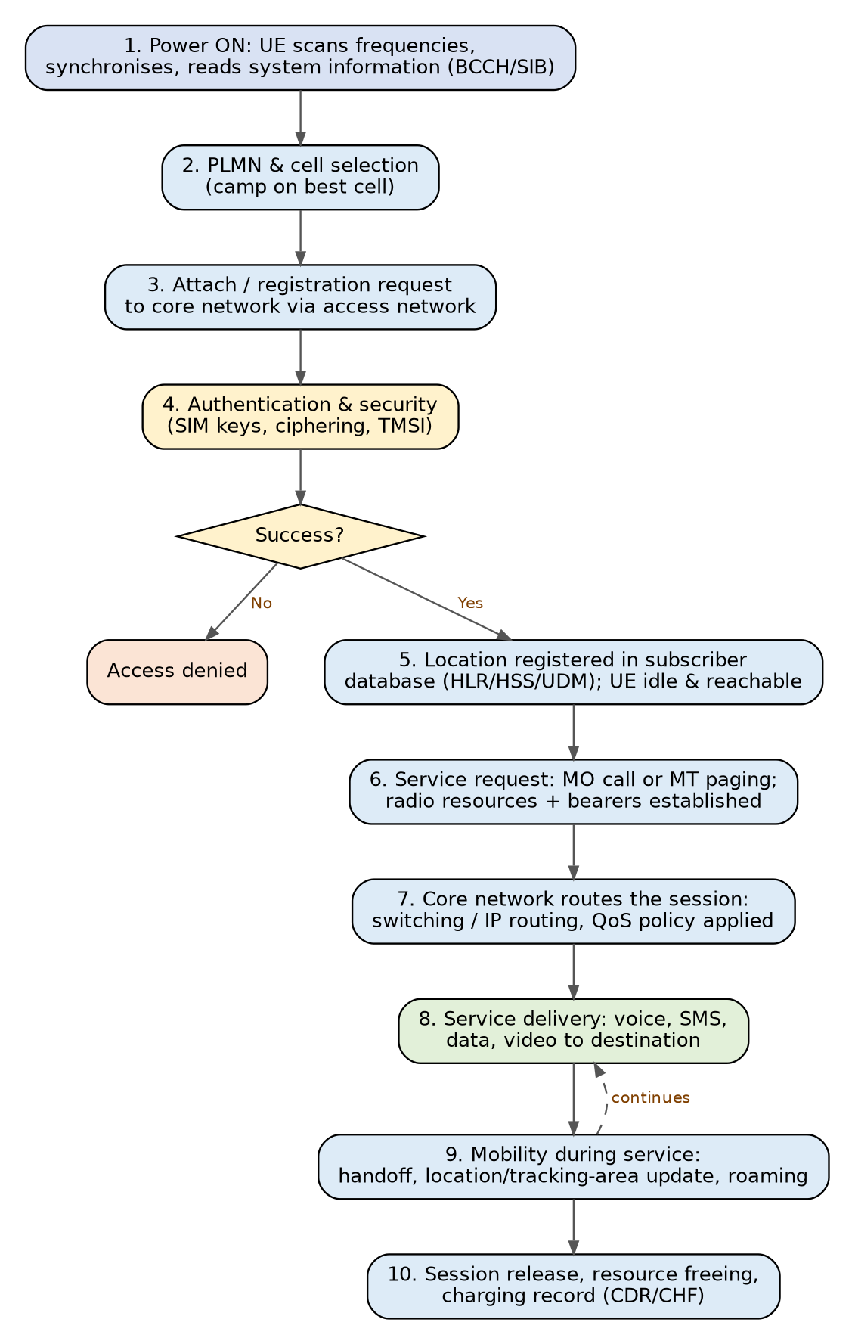
Figure 15.2 – End-to-end flowchart from power-on to session release

6. Explanation of the Stages
- Power-on and synchronisation: The UE searches frequencies, locks to the strongest cell using synchronisation channels (FCCH/SCH or PSS/SSS) and reads system information on BCCH/SIB.
- PLMN and cell selection: The UE selects the home or an allowed visited network and camps on the best cell based on signal strength and quality.
- Attach / registration: The UE sends an attach or location-update request carrying its identity; the access network forwards it to the core.
- Authentication and security: The network verifies the SIM, starts ciphering and integrity protection and gives a temporary identity (TMSI/GUTI).
- Location registration: The subscriber database records the serving node and area; the UE enters idle mode but remains reachable.
- Service request: For an outgoing call, the UE requests resources; for an incoming one, paging occurs. Radio bearers and core bearers (tunnels/circuits) are established with the required QoS.
- Core routing: The core switches the call or routes IP packets to the destination (another mobile, PSTN, internet server) and applies policy and charging rules.
- Service delivery: Voice, SMS, data or video flows to the destination; codecs, buffering and error control maintain quality.
- Mobility during service: Handoff, tracking-area updates and roaming keep the session alive while the user moves.
- Release and charging: On completion resources are freed and a charging record is produced.

7. Assessment – Most Critical Stages for Communication Quality
Rank | Stage | Why it is critical | Quality factor affected
1 | Radio access and resource allocation (stage 6) | The radio link is the scarcest, most variable and error-prone part; interference, fading and congestion arise here. | Voice clarity, throughput, blocking, delay
2 | Authentication & security (stage 4) | No service is possible without a valid identity; also prevents fraud and eavesdropping. | Security, trust, accurate billing
3 | Mobility management / handoff (stage 9) | Maintains continuity as the user moves. | Call drops, interruption time
4 | Core routing and QoS (stage 7) | Determines end-to-end path, congestion, priority and latency. | Delay, jitter, packet loss
5 | Registration (stage 5) | Provides reachability for incoming calls. | Missed calls, setup time
6 | Service delivery (stage 8) | Final quality depends on codecs, buffering and the application. | MOS, video smoothness
7 | Release and charging (stage 10) | Frees resources and ensures correct billing; indirectly affects quality by recycling capacity. | Capacity, billing accuracy
Evaluation: The air interface (radio access with resource management) is generally the bottleneck for quality, followed by security and mobility management, which are mandatory conditions for continuous service. The core network is usually engineered for high capacity and high reliability, so it more rarely limits quality, but it determines latency and QoS enforcement.

8. Additional Information
- Mapping to protocol layers: Physical layer (modulation, coding, MIMO) → data-link (MAC/RLC/PDCP, error correction, ARQ) → network (RRC/NAS signalling, IP) → transport and application (TCP/UDP, SIP, HTTP, voice codecs).
- Control plane vs user plane: Control plane carries signalling (attach, authentication, handoff); user plane carries actual voice/data. 4G and 5G separate them (e.g., SGW-C/U, SMF vs UPF) for better scalability.
- Generation comparison: 2G (GSM) – circuit-switched digital voice and SMS; 2.5G (GPRS/EDGE) – packet data; 3G (UMTS/HSPA) – mobile broadband and soft handoff; 4G (LTE) – all-IP, OFDMA, VoLTE; 5G (NR) – eMBB, URLLC, mMTC, network slicing, service-based architecture.
- End-to-end delay budget (example, voice): codec ≈ 20–40 ms + radio ≈ 5–20 ms + transport/core ≈ 10–30 ms + jitter buffer ≈ 20–60 ms, which should keep one-way delay under about 150 ms.
- Quality tools: Link adaptation, power control, HARQ, QoS classes, load balancing, self-organising networks (SON) and drive-test/OSS monitoring.

9. Conclusion
Mobile communication is an end-to-end chain: UE → access network → core network → service, with mobility management and security acting across all of them. The concept map shows that quality is decided mostly at the radio access stage, while authentication, mobility management and core QoS control provide the conditions that keep communication secure, continuous and consistent. The overall system is only as good as its weakest stage.

